Individual Logbook

Week 12
Dave Sushames
2026
Contents
Table 1
Discussion 1

Table
Category | Hours Completed
Team meetings | 3
Client meetings
Advisor meetings | 4
Research | 1h 50m
Development
Testing
Documentation | 4h 30m
Logbook preparation
Other
Total hours for this week | 11h 20m
Running total of hours completed for Capstone | 292h 25m + This week total

Logbook content notes
Team meetings:
Tuesday 10-12
Tuesday 5:30-6:30: Going over the Review with Matt and Sam, figuring out the bits that need work.
Friday 11-12: Debrief after meeting with Bryce, discussing what team members will be doing today, which reports still need to be written and by whom.
Client meetings:
Advisor meetings:
Monday 2-3 Weekly meeting with Dax.
Tuesday 9-10
Friday 9-11
Research
See research log
Development
Thursday 9-11 Looking at Nmap scans and reports, figuring out what information Nmap reports actually mention.
Thursday 11-12:30 Making an Nmap report based on the 28sepServiceScan.xml file. 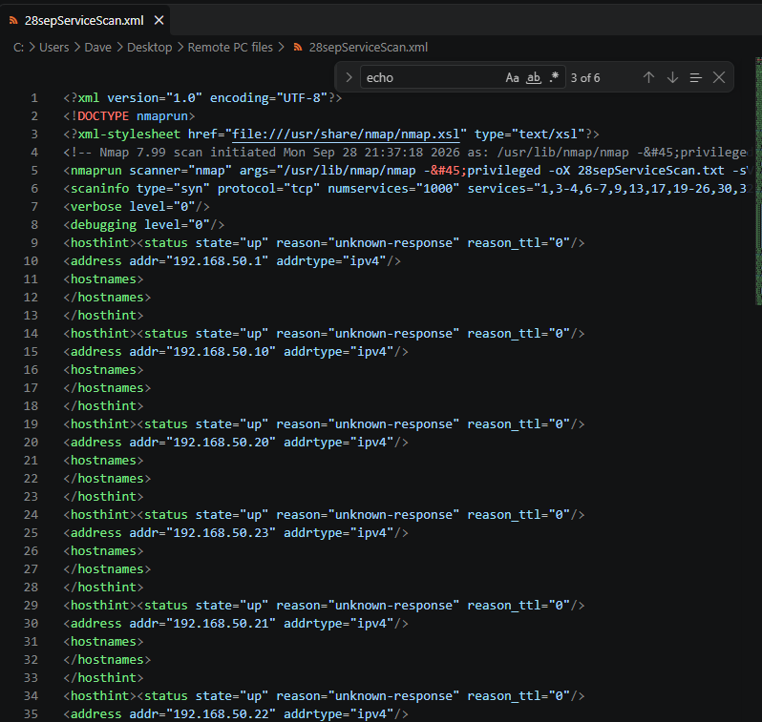
1:15 - 4:45 More work on the Nmap report 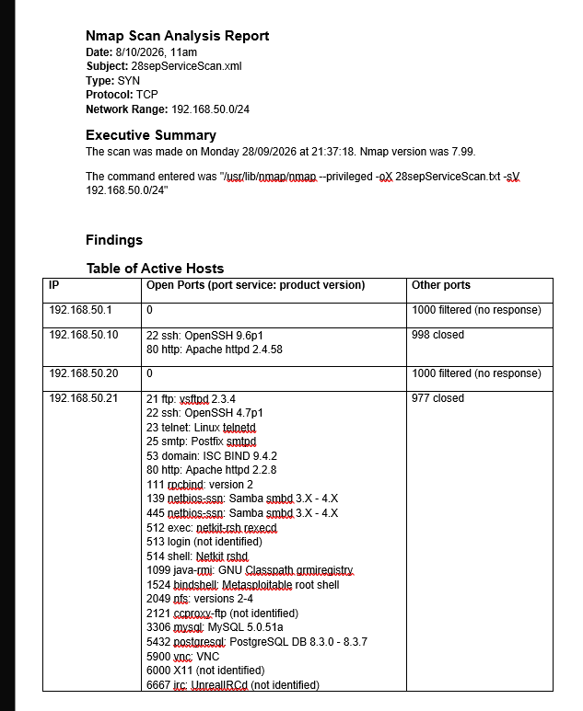
8:30-9: more Nmap
12:45-1pm Finished the Nmap report. 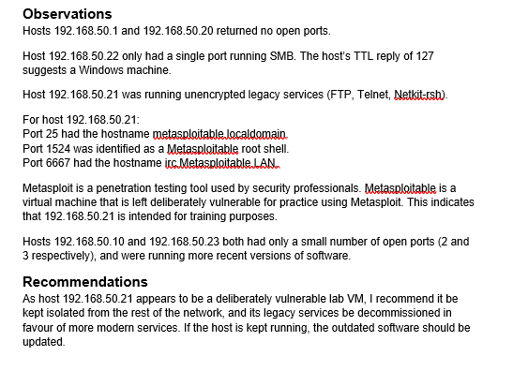
Documentation
Monday 1-2pm: Working on the Gantt chart with Olivia.
Tuesday 8:30-9am: Working on the Self Management Review.
Tuesday 12:45-3:45: Working on the Self Management Review, specifically the formatting of the sections, and discussing the Gantt charts. 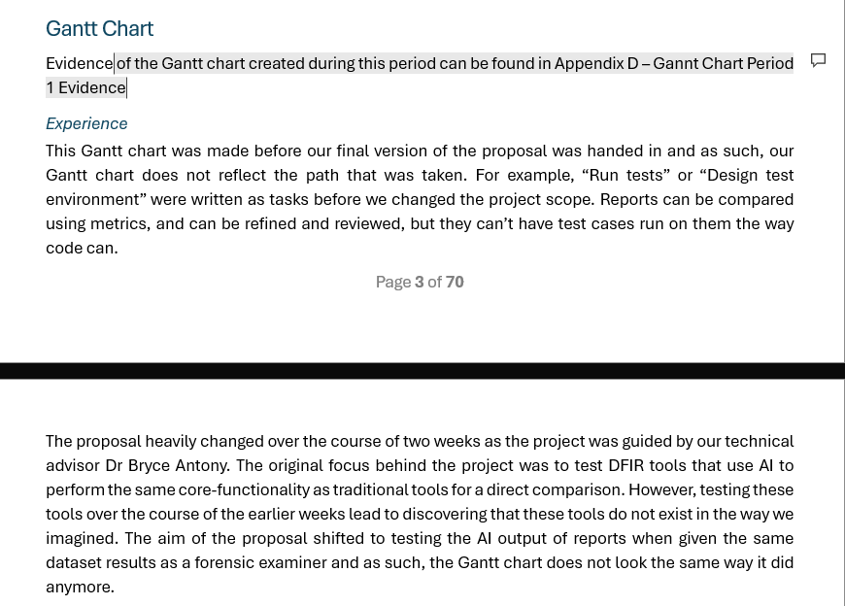
Wednesday 9-12:45: Finishing the Self-management review. Editing, final changes, fixing the formatting. Made sure each new section is on its own page, removed any concatenations, and any personal pronouns in the text that weren’t part of team members’ personal reflection sections.
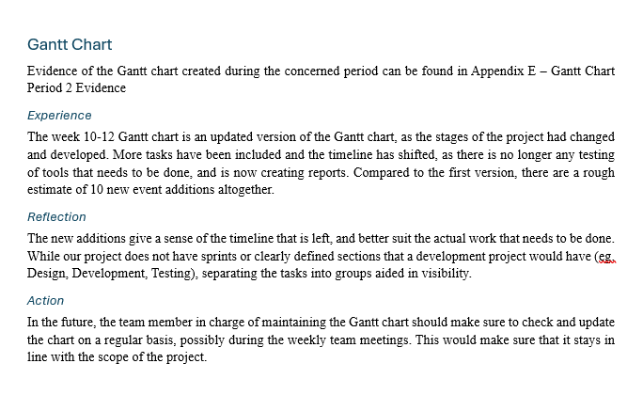
Wednesday 2-4:45pm. Started work on the final panel presentation slides. Laying out the slide structure and basic content each slide would have.
